NAD Electronics
December 11, 2007

IR Channel Explanation

Current Supported Models
- Txx5 AVRs
- M4 Tuner

There is a new feature, called IR Channels, on the Txx5 series receivers. This feature is not documented within the owner’s manual and is only available in MCU firmware version 1.08 and higher. This feature allows for two NAD receivers to be controlled separately using IR. The default channel on the Txx5 AVRs is channel 0. Alternatively, this can also be set to channel 1.

Zone2 is somewhat special because it responds to both the older discrete IR Zone commands and channel 2 commands. Zone3 and Zone4 only respond to channel 3 and channel 4 IR commands.

Commands with a channel number greater than 0 are no longer standard NEC. This means that any software program or remote which can be programmed by simply taking the NEC customer code and IR data command, will not work with channels greater than 0. There are two options for these devices, to either use a pronto code including the desired channel number or to learn the commands including the desired channel directly from an NAD HTR remote.

To obtain the pronto code including the desired channel you can use the NADToPronto.exe program. A new feature has been added to the program to allow you to set the channel for any Txx5 receiver IR command. For a sample screenshot please see below.

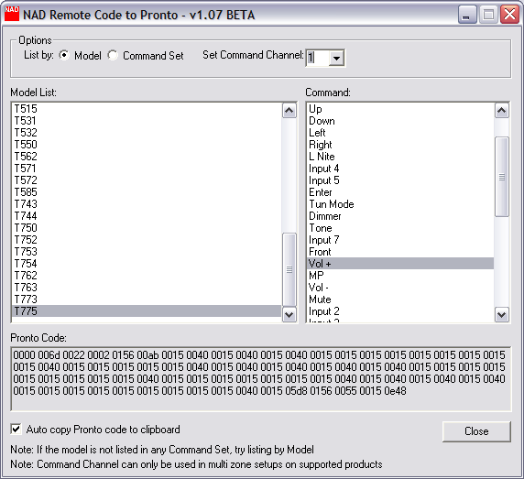

Change Main IR Channel on Txx5 AVR
To toggle the IR channel press the “Source <” and “Power” front panel buttons on the same time. The VFD will display what the IR Channel is set to.

Change IR Channel on HTR Remote
Usually HTR code tables are three digits, for example a receiver with discrete on/off commands is table 100. If you want to load this table into a device key using IR channel 1 you would enter the table as 1100. If instead you want to load this table into a device key using IR channel 4 you would enter the table as 4100. If you only enter a three digit number, channel 0 is assumed.

Note: If you have an HTR2 or HTRM remote, you may need to upgrade it’s firmware to support IR channels.

